6

**A**

**PROJECT REPORT**

**ON**

**“SPINCITY CYCLES”**

**For**

**SYBBA(CA)**

**Submitted By**

Sahil Binjwe (Roll No.3205)

Prathamesh Darvatkar (Roll No.3208)

**SUBMITTED TO**

# Vishwakarma College of Arts, Commerce & Science.

# Shanti Nagar Kondhwa, pune-411048



Bansilal Ramnath Agarwal Charitable Trust’



**VISHWAKARMA COLLEGE OF ARTS, COMMERCE SCIENCE, PUNE**

Kondhwa Bk., Pune-411048

CERTIFICATE

**This is to certify that,**

**Mr./Mrs.________________________________________________**

**Of______________________________class has completed project**

**Report on_______________________________________________**

**_______________________________________________________**

**Practical work in the Department of_________________________ As prescribed by the Savitribai Phule University, in the academic year 2023-2024.**

**Principal Internal Examiner External Examiner**

**Date:**

**Remark:**

ACKNOWLEDGEMENT

I extend my deepest appreciation to my esteemed guid,**Ritika Choudhary** for providing me with the possible to complete this project with the right guidance and advice.

Special gratitude I give to my respected head of the Department **Dr Shudir Chitnis** ,for allowing me to use the facilities available and also help me to coordinate my project. Furthermore, I would also like to acknowledge with much appreciation the crucial role of faculty member on this occasion.

Last but not least,I would like to thank friends who help me to assemble the parts and gave a suggestion about the project.

DECLARATION

We the undersigned hereby declare that the project work entitled “_______________” submitted to the Savitribai Phule,Pune University is the record on an original work done by us for the partial fulfilment of: Bachelor of Business Administration (Computer Application) Academic year 2023-2024 under the guidance of Ritika Choudhary .Findings and conclusions are based on the material collected by me. This project has not been submitted or published on any other college or institutes before.

Student Name: Sahil Binjwe , Prathamesh Darvatkar

Roll No:   3205 , 3208

Class & Sem: SYBBA(CA) Sem-IV

Seat No:

Date:

Place:

Index

|  |  |  |
| --- | --- | --- |
| Sr.No | **Particulars** | **Page No.** |
| **1** | ABSTRACT |  |
| **2** | **2.1** INTRODUCTION  **2.2** Motivation  **2.3** Problem Statement  **2.4** Purpose / Objective and Goals  **2.5** Literature Survey  **2.6** Project Scope and Limitation  **2.7** Methodology |  |
| **3** | System Analysis  **3.1** Existing System  **3.2** Project perspective: Features  **3.3** Stakeholders  **3.4** Requirement analysis |  |
| **4** | System Design  **4.1** ER Diagram  **4.2** DFD Diagrams  **4.3** System flow Diagram  **4.3** User Interface (input and output screen) |  |
| **5** | Implementation Details  **5.1** Software/Hardware Details |  |
| **6** | Conclusion |  |
| **7** | Future Scope |  |
| **8** | Bibliography and References |  |

1. ABSTRACT

Online cycle shops have revolutionized the way people buy bicycles. With just a few clicks, you have access to a vast selection of bikes, ranging from road bikes to mountain bikes, and everything in between. These websites provide a convenient and hassle-free shopping experience, allowing you to explore different brands, models, and specifications without leaving your home.

When it comes to purchasing a bike online, you'll typically find detailed product descriptions, including specifications, sizing charts, and compatibility information. This helps you make an informed decision and choose the right bike for your needs. Some online shops even provide virtual bike fitting tools, allowing you to input your measurements and receive personalized recommendations.

In terms of customer support, online cycle shops often have dedicated teams that can assist you with any queries or concerns you may have.

So, whether you're a seasoned cyclist or a beginner looking to start your cycling journey, online cycle shops offer a convenient, comprehensive, and reliable way to find and purchase your dream bike.

Happy cycling!

1. 2.1) INTRODUCTION

Welcome to our SpinCity Cycle Shop – your digital haven for all things cycling! As passionate cyclists ourselves, we've curated a diverse collection of top quality bicycles and accessories to cater to riders of every level. From sleek road bikes to rugged mountain cycles, our virtual shelves are stocked with options that marry performance and style.

SpinCity cycle shop typically have a user-friendly interface that allows you to easily navigate through their product listings. You can browse through different categories such as road bikes, mountain bikes, hybrid bikes, and more. We often provide detailed descriptions, specifications, and high resolution images of each bike, giving you a good idea of what to expect.

Navigate through our user-friendly website to discover an array of cycling gear, from helmets and apparel to maintenance tools, ensuring you're equipped for every ride. Our commitment to excellence guarantees that each product meets the highest standards, providing you with the confidence to conquer any terrain.

2.2) MOTIVATION

The motivation behind the creation of the Cycle Shop website stems from a deep-seated belief in the transformative power of cycling. As advocates for sustainability, health, and community, we recognize cycling as more than just a mode of transportation or a recreational activity – it's a way of life.

First and foremost, Spincity Cycles website is driven by a commitment to sustainability. Cycling presents a compelling solution, offering a clean, green, and sustainable way to commute, exercise, and explore the world around us. By providing a platform dedicated to cycling, we aim to inspire individuals to embrace biking as a means of reducing their carbon footprint and preserving the planet for future generations.

Furthermore, the Cycle Shop website seeks to promote a culture of health and wellness. Whether it's a leisurely ride through the countryside or an intense mountain biking adventure, cycling provides countless opportunities for physical activity and enjoyment. Through our platform, we hope to encourage individuals of all ages and fitness levels to incorporate cycling into their daily routines, thereby fostering healthier, happier communities.

Additionally, our Cycle Shop website aims to build a vibrant and inclusive cycling community. We recognize that cycling is more than just a solitary pursuit – it's a shared passion that brings people together from all walks of life. By creating an online hub where cyclists can connect, collaborate, and share their experiences, we seek to foster a sense of camaraderie and belonging within the cycling community.

In summary, our Spincity Cycles website is motivated by a desire to promote sustainability, health, and community through the power of cycling

2.3) PROBLEM STATEMENT

Spincity Cycles website addresses several key challenges faced by cycling enthusiasts in accessing quality products, fostering community engagement, and promoting sustainable lifestyle choices:

1. Limited Access to Quality Products: Many cyclists struggle to find a diverse selection of high-quality bicycles and accessories in their local area. As a result, cyclists may settle for subpar equipment or incur significant time and expense in sourcing products from distant locations.

2. Lack of Community Engagement: Traditional retail outlets often lack the interactive features and community-building tools necessary to facilitate meaningful engagement among cyclists.

3. Environmental Impact of Transportation: Despite the environmental benefits of cycling as a sustainable mode of transportation, many individuals remain hesitant to adopt biking as a viable alternative due to perceived barriers such as safety concerns, lack of infrastructure, and inadequate access to cycling resources.

4. Fragmented Online Shopping Experience: Cyclists may encounter difficulties in navigating cluttered websites, discerning product quality, and making informed purchasing decisions. Moreover, concerns regarding data privacy, payment security, and customer support may deter users from completing transactions on certain platforms.

2.4) PURPOSE AND GOALS

Purpose:

Spincity Cycles website endeavors to serve as a premier online destination for cyclists, providing a comprehensive platform that caters to the diverse needs and interests of cycling enthusiasts worldwide. By offering a curated selection of high-quality bicycles, accessories, and apparel, the website aims to empower individuals to pursue their cycling passions, adopt sustainable lifestyle choices, and connect with like-minded individuals within the cycling community.

Goals:

1. Provide Access to Quality Products: The primary goal of our Cycle Shop website is to offer a diverse and carefully curated selection of bicycles, accessories, and apparel from leading brands in the cycling industry.

2. Foster Community Engagement: Through interactive features such as forums, socialnetworking tools, and user-generated content, we aim to create a space where cyclists can connect, share experiences, exchange tips and advice, and support one another in their cycling journey.

3. Promote Sustainability: Spincity Cycles website is committed to promoting sustainabilityand eco-conscious practices within the cycling community. Through educational resources, eco-friendly product offerings, and advocacy initiatives, we aim to raise awareness about the environmental benefits of cycling as a sustainable mode of transportation and lifestyle choice.

4. Deliver Exceptional User Experience: Our goal is to provide users with a user-friendly interface, easy navigation, and efficient search functionality, allowing them to find and purchase products quickly and effortlessly.

2.5) LITERATURE SURVEY

1. E-commerce Platforms in the Cycling Industry: Previous studies have explored the role of e-commerce platforms in the cycling industry, highlighting the importance of user experience, product selection, and customer service in driving online sales.

2. Community Building in Online Cycling Communities: Studies have explored the role of social networking tools, user-generated content, and virtual events in fostering engagement and building a sense of community among cyclists.

3. Sustainability Initiatives in the Cycling Industry: Studies have examined the environmental benefits of cycling as a low-carbon mode of transportation and explored strategies for promoting cycling as a sustainable lifestyle choice.

2.6) PROJECT SCOPE AND LIMITATION

Scope:

1. E-commerce Functionality: Spincity Cycles website will provide a platform for users to browse, search, and purchase a wide range of bicycles, accessories, and apparel online.

2. Sustainability Initiatives: The website will promote sustainability by offering eco-friendly products, providing educational resources on sustainable cycling practices, and supporting environmental advocacy efforts within the cycling community.

3. Mobile Compatibility: The website will be optimized for mobile devices to ensure a seamless browsing and shopping experience for users accessing the site from smartphones and tablets.

4.Wide Product Range: Online cycle shops offer a diverse range of bicycles, accessories, and gear, providing customers with an extensive selection to suit various preferences and needs.

5. Convenience and Accessibility: Customers can shop anytime, anywhere, eliminating the need to visit physical stores. The 24/7 accessibility enhances convenience, particularly for busy individuals or those with tight schedules.

6. Customer Reviews and Ratings: Access to customer reviews and ratings allows potential buyers to gauge the quality and performance of products, contributing to a more transparent and trustworthy shopping environment.

Limitations:

1. Limited Physical Inspection: Customers cannot physically examine bicycles before purchasing, potentially leading to dissatisfaction if the product doesn't meet their expectations.

2. Sizing Challenges: Choosing the right size online can be tricky, increasing the likelihood of discomfort or inconvenience if the bicycle doesn't fit the customer properly.

3. Lack of Test Rides: Online shops often don't offer the option for test rides, making it challenging for customers to experience the feel of the bicycle before making a purchase decision.

2.7) METHODOLOGY

1. Requirement Analysis: We have conducted a thorough analysis of user requirements, business objectives, and industry trends to define the scope and features of the Spincity Cycles website.

2. Design Phase:

- User Experience Design: Developed wireframes, mockups, and prototypes to outline the layout, navigation flow, and visual design of the website.

- Database Design: We have desogned the database schema, data tables, and relationships to efficiently store and manage product data, user information, and other relevant data for the website.

- System Architecture Design: Define the technical architecture, including the technology stack, server infrastructure, and software components needed to support the website's functionality and scalability.

3. Development Phase:

- Frontend Development: Implement the frontend of the website using HTML, CSS, and JavaScript to create responsive web pages that render properly across various devices and screen sizes.

- Backend Development: Develop the backend logic and server-side functionality using programming languages such as (Python, Ruby, or PHP). This includes implementing features such as user authentication, product catalog management, and payment processing.

- Database Implementation: Spincity Cycles website has the database system and implement data storage, retrieval, and manipulation functionalities according to the defined database design.

4. Testing and Quality Assurance:

- Unit Testing : Tested individual components and modules of the website to ensure they function correctly in isolation.

- Integration Testing: Verified the integration and interaction between different components of the website to ensure they work together as intended.

- Performance Testing: Measure and optimize the website's performance, including page l oad times, server response times, and scalability under different levels of traffic.

5. Deployment and Launch:

- Deployed Spincity Cycles website to production servers and configure the necessary infrastructure to make it accessible to users.

- Performed final checks and validations to ensure that the website is functioning correctly and ready for public release.

-Launched the website

6. Maintenance and Iteration:

- Monitored the performance and stability of the website post-launch, addressing any issues or bugs that arise promptly.

- Continuously iterate and refine Spincity Cycles website based on user feedback, industry trends, and evolving business requirements to ensure its long-term success and relevance in the market

3) SYSTEM ANALYSIS

1. User Requirements Gathering: The first step in system analysis for Spincity Cycles website involves gathering user requirements through surveys, interviews, and market research. This includes understanding the preferences, needs, and pain points of cyclists, as well as identifying key features and functionalities desired in an online cycling platform.

2. Functional Requirements Definition: Based on the user requirements gathered, the next phase involves defining the functional requirements of the website. This includes specifying features such as product catalog management, user account registration, search and filtering options, shopping cart functionality, secure payment processing and customer support.

3. Non-functional Requirements Specification: In addition to functional requirements, non-functional requirements are defined to ensure the performance, reliability, security, and usability of our website. This includes considerations such as website responsiveness, loading speed, scalability, data privacy, payment security compliance.

4. System Architecture Design: The system architecture of Spincity Cycles website is designed based on the defined requirements, considering factors such as scalability, modularity, and integration with third-party systems. This includes determining the technology stack, database structure, server infrastructure, and software components needed to support the website's functionality.

5. Database Design: A robust database design is essential for storing and managing product data, user information, order details, and other essential data for the Cycle Shop website.

3.1) EXISTING SYSTEMS

1. Existing E-commerce Platforms: There are numerous existing e-commerce platforms catering to the sale of bicycles, accessories, and related products. Examples include major platforms like Amazon, eBay, etc.

2. Online Cycling Communities and Forums: There are also existing online communities and forums dedicated to cycling. Examples include websites like BikeRadar, RoadBikeReview, etc.

3. Brick-and-Mortar Bicycle Shops: While the focus is on online platforms, traditional brick-and-mortar bicycle shops remain a significant part of the cycling industry. These shops offer a physical location for customers to browse and purchase bicycles, accessories, and receive personalized assistance from knowledgeable staff.

4. Manufacturer Websites: Many bicycle manufacturers have their own websites where they sell their products directly to consumers. These websites often provide detailed information about their product lineup, including specifications, pricing, and availability.

3.2) PROJECT PERSPECTIVE: FEATURES

1. Comprehensive Product Catalog: Spincity Cycles website will feature a comprehensive catalog of bicycles, accessories, and apparel from leading brands in the cycling industry. This includes a diverse range of products tailored to different types of cyclists, such as road bikes, mountain bikes, hybrid bikes, helmets, apparel, and bike components.

2. User-Friendly Interface: The website will have a user-friendly interface designed to provide an intuitive browsing and shopping experience for customers. This includes easy navigation, clear product categorization, and advanced search and filtering options to help users find the products they need quickly and efficiently.

3. Secure Payment Processing: The website will prioritize the security of online transactions by implementing robust payment processing systems and encryption protocols. This ensures that customers' payment information is protected and that transactions are conducted securely.

4. Responsive Customer Support: The Cycle Shop website will offer responsive customer support channels, including live chat, email support, and a dedicated customer service hotline. This allows users to seek assistance, ask questions, and resolve any issues or concerns they may encounter during their shopping experience.

5. Sustainability Initiatives: As part of its commitment to sustainability, Spincity Cycles website will promote eco-friendly products, recycling programs, and advocacy efforts to reduce the environmental impact of cycling. This aligns with the values of environmentally conscious cyclists and contributes to a more sustainable cycling community.

6. Mobile Compatibility: The website will be optimized for mobile devices to ensure a seamless browsing and shopping experience for users accessing the site from smartphones and tablets. This includes responsive design, mobile-friendly navigation, and fast loading times to accommodate users on the go.

3.3) STAKEHOLDERS

1. Customers: The primary stakeholders of the Cycle Shop website are the customers, including cycling enthusiasts, hobbyists, and professionals. They are the end-users of the website and play a crucial role in driving sales, providing feedback, and shaping the overall user experience.

2. Website Administrators: Website administrators are responsible for managing and maintaining the Cycle Shop website. They oversee tasks such as product updates, content management, order fulfillment, customer support, and website performance monitoring.

3. Cycling Brands and Manufacturers: Cycling brands and manufacturers are stakeholders in the Spincity Cycles website as they supply the products available for sale on the platform.

4. Shipping and Logistics Partners: Shipping and logistics partners are involved in the delivery of products purchased through the website. Their performance directly impacts customer satisfaction and the reputation of the website.

5. Payment Service Providers: Payment service providers facilitate secure payment processing for transactions conducted our website.

3.4) REQUIREMENT ANALYSIS

1. User Authentication and Account Management: Users are able to create accounts, log in securely, and manage their profiles.

2. Product Catalog: Spincity Cycles website have a comprehensive catalog of bicycles, accessories, and apparel. Each product listing includes detailed descriptions, specifications, pricing, and high-quality images.

3. Shopping Cart and Checkout: Users are able to add items to their shopping cart, review their selections, and proceed to checkout securely. The checkout process include options for shipping, payment, and order confirmation.

4. Payment Processing: Spincity Cycles website support secure payment processing, including major credit cards, debit cards, and other popular payment methods.

5. Responsive Design: The website is responsive and optimized for various devices and screen sizes, including desktops, laptops, tablets, and smartphones. We ensures a consistent and user-friendly experience across all platforms.

6. Customer Support: Spincity Cycles website provide channels for customer support, including live chat, email support, and a help center with FAQs and troubleshooting guides. This ensures that users can receive assistance and resolve issues promptly.

4) SYSTEM DESIGN

4.1) ER DIAGRAM

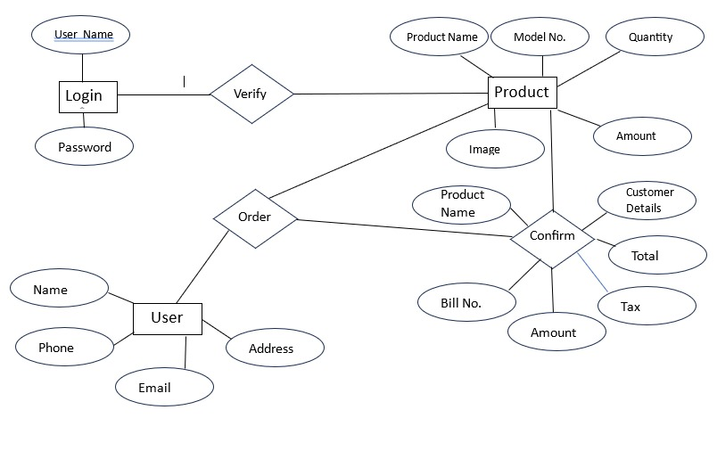

4.2) DFD DIAGRAM

**LEVEL ZERO:**

Customer Details Management

Booking management

Cycle Showroom Management System

Cycle Management

Delivery Management

Payment Management

**ZERO LEVEL DFD CYCLE SHOWROOM MANAGEMENT SYSTEM**

**LEVEL ONE:**

Cycle Showroom management System

Booking Management

Cycle Management

Delivery Management

Generate Booking Report

Generate Cycle Report

Check Delivery details

**FIRST LEVEL DFD CYCLE SHOWROOM MANAGEMENT DETAILS**

**LEVEL SECOND:**

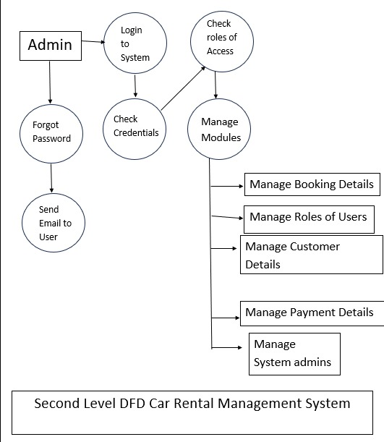

4.3) SYSTEM FLOW DIAGRAM

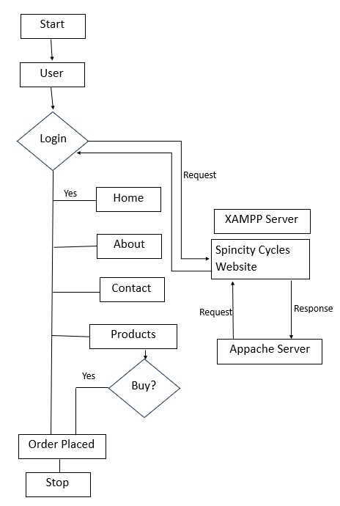

4.4) USER INTERFACE (INPUT AND OUTPUT SCREEN

**Input Screen**

**LANDING PAGE:**

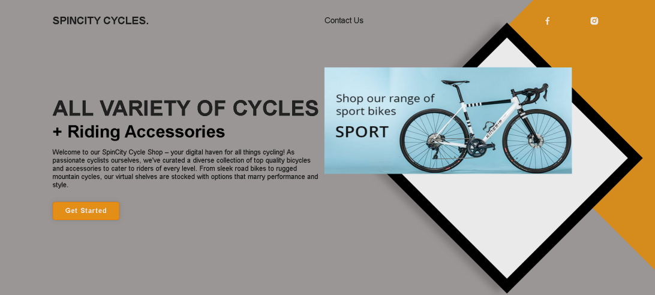

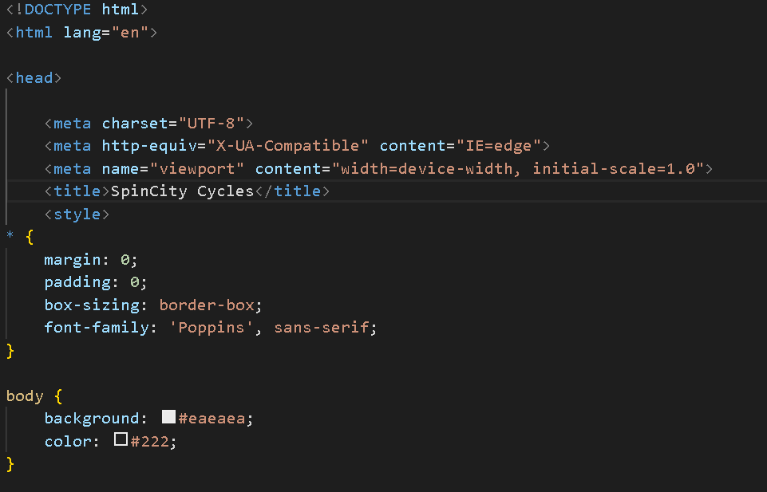

**LOGIN PAGE:**



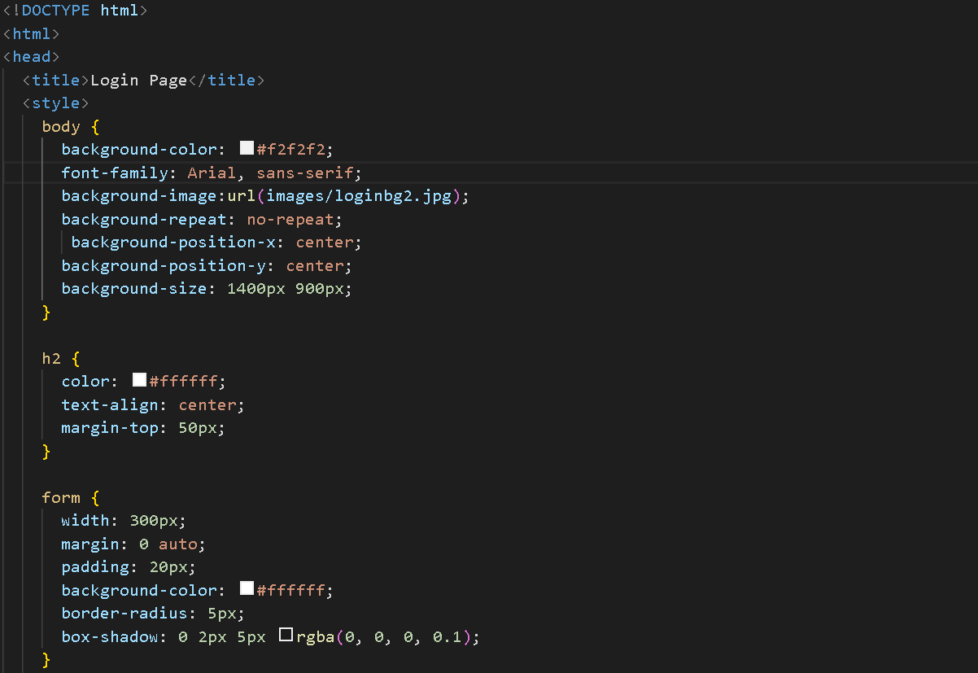

**HOME PAGE:**

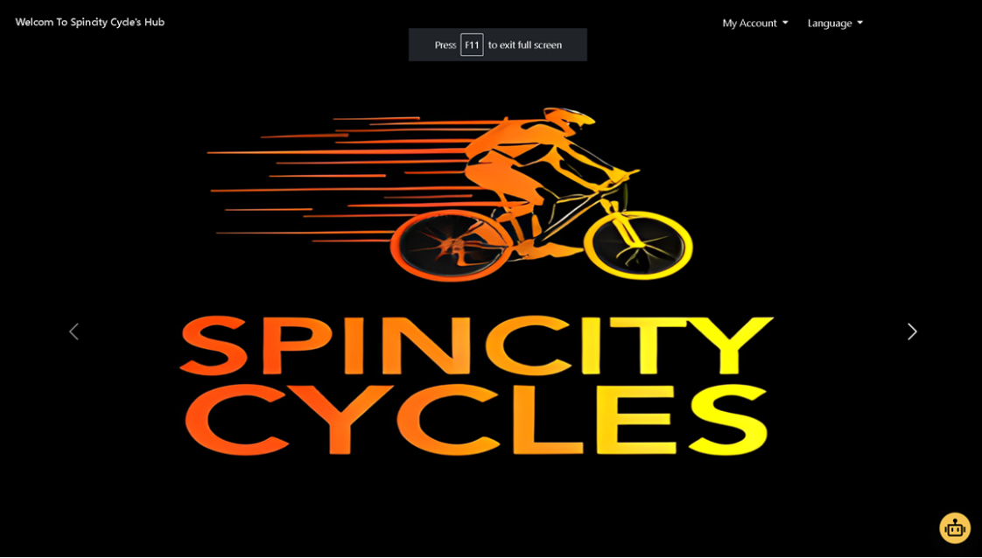

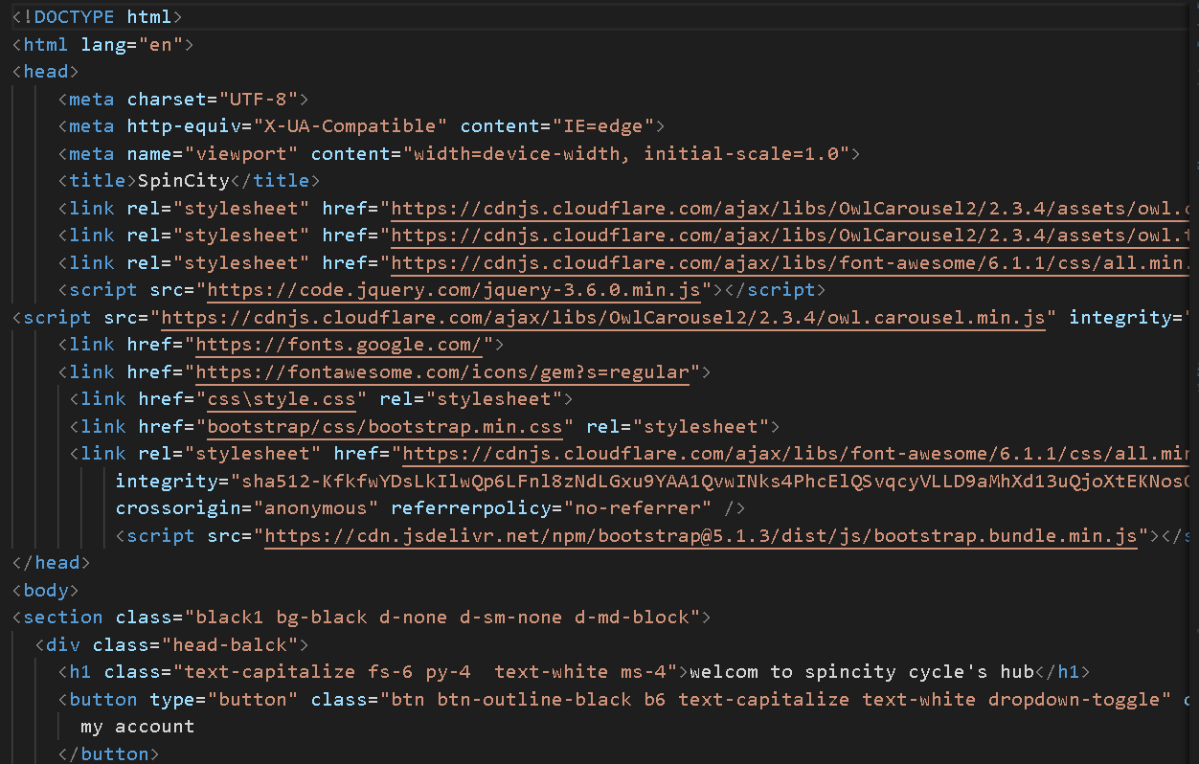

**CONTACT US:**



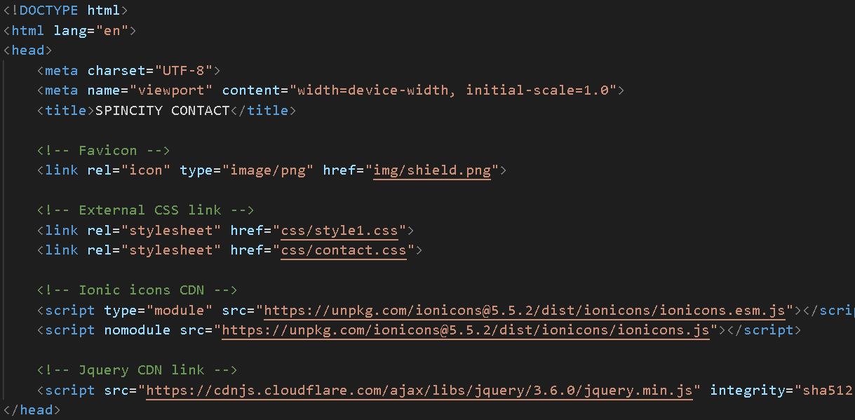

**ABOUT US:**

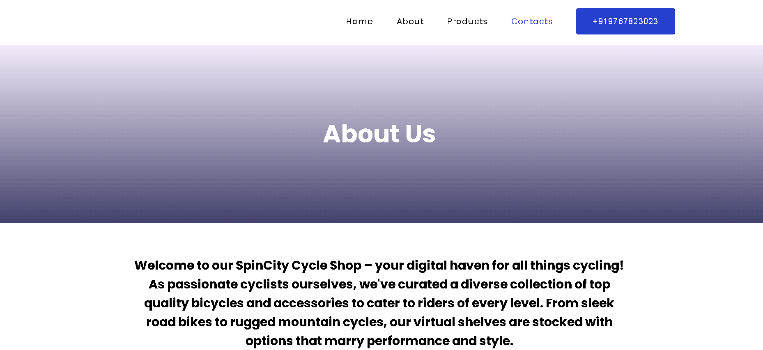

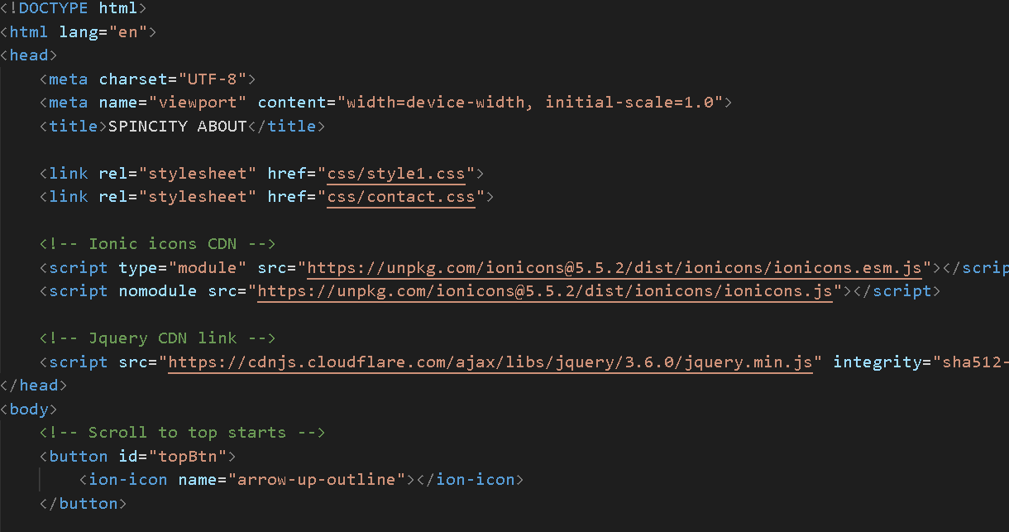

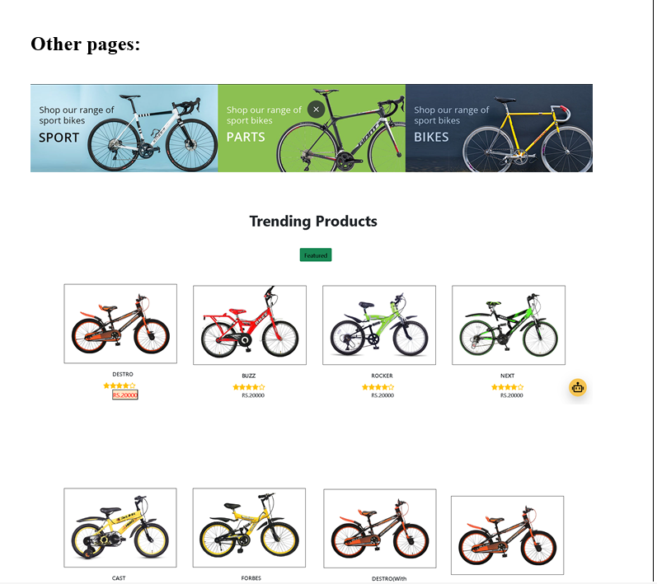

**Home Page**

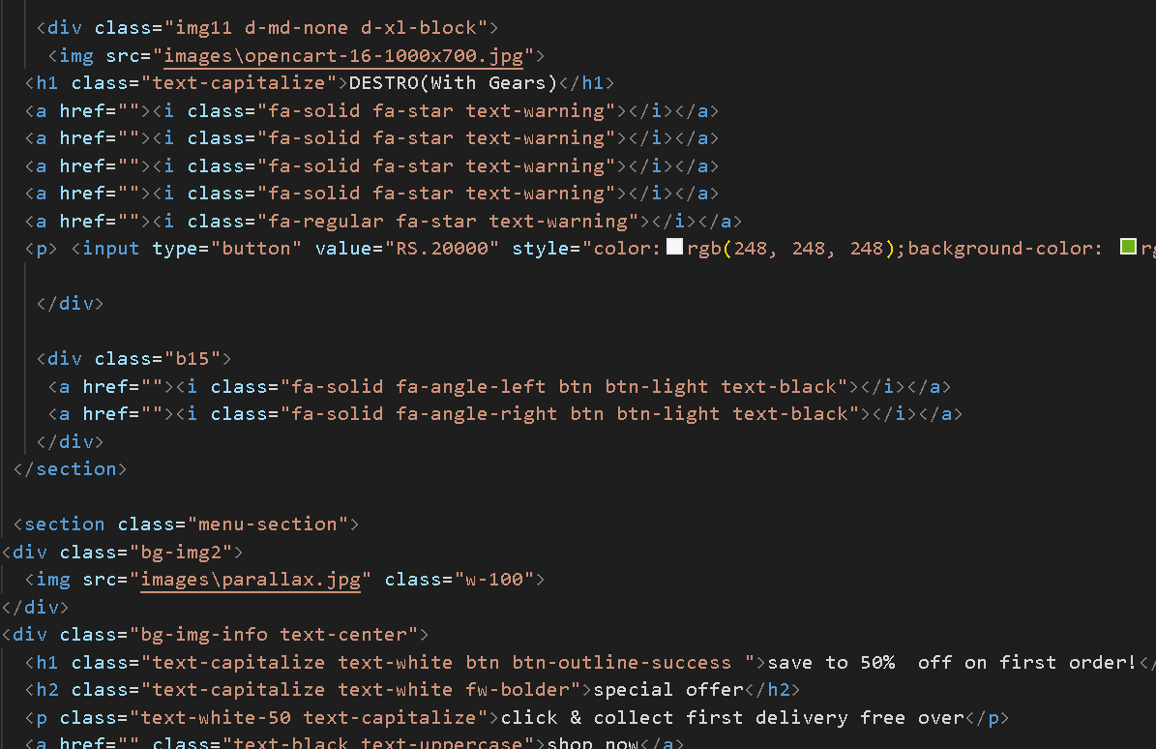

**Chat Bot:**

**OUTPUT SCREEN:**

**LOGIN PAGE**

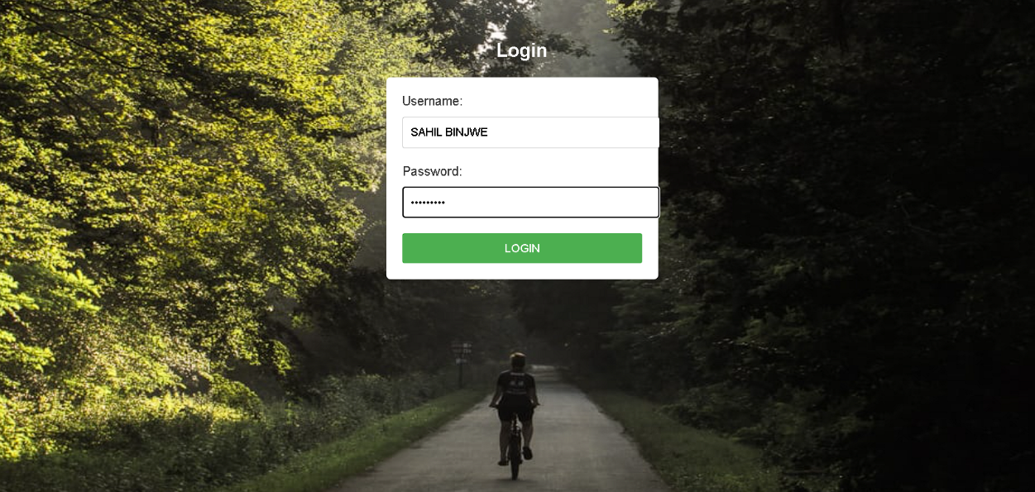

**CHAT BOX**

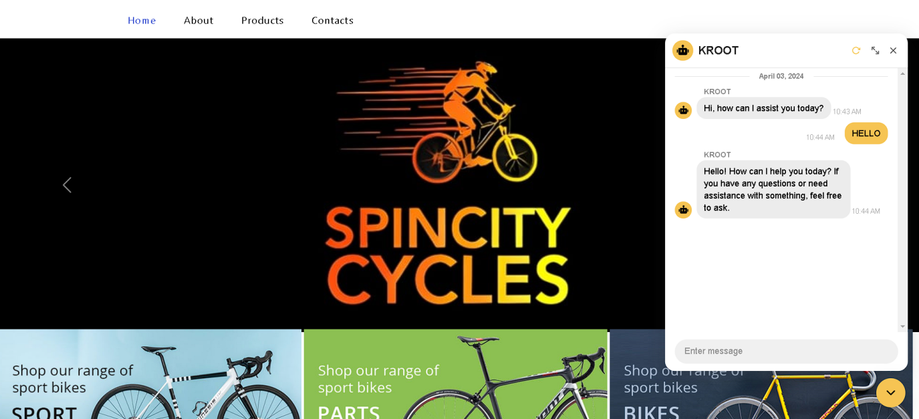

1. IMPLEMENTATION DETAILS

**\*HARDWARE REQUIREMENTS:**

1. Core i5 generation.
2. Windows 10/11.
3. Ram 4 GB.

*SOFTWARE REQUIREMENTS:

1. Visual Studio Code.
2. Chrome Browser.

*LANGUAGE :

1.HTML

2.CSS

3.JAVASCRIPT

4.BOOTSTRAP

6).CONCLUSION

Cycle Shop website provides a user-friendly platform for cycling enthusiasts to explore and purchase a wide range of high-quality bicycles and accessories. With its intuitive navigation, detailed product descriptions, and secure payment options, the website aims to enhance the overall shopping experience for customers. Whether you're a seasoned cyclist or a novice looking to start your cycling journey, the Cycle Shop website strives to meet your needs and contribute to a seamless and enjoyable shopping experience.

Overall, the Cycle Shop website not only serves as an e-commerce platform but also as a comprehensive resource for cycling enthusiasts, fostering a connection with the cycling community and promoting a healthy and sustainable lifestyle.

7).FUTURE SCOPE

1. Mobile App Development: Develop a dedicated mobile app for Spincity Cycles website to provide users with a seamless and optimized shopping experience on smartphones and tablets. The app can leverage device-specific features and push notifications to enhance user engagement and retention.

2. Omnichannel Integration: Integrate offline and online channels to create an omnichannel shopping experience for users. Explore options for click-and-collect services, in-store pickup, and seamless integration between online and brick-and-mortar retail channels to provide customers with flexibility and convenience.

3. Community Building Initiatives: Expand community engagement efforts through partnerships with cycling clubs, events, and advocacy groups. Organize virtual and in-person events, workshops, and group rides to foster a sense of community and promote engagement among users.

4. Sustainability Initiatives: Strengthen sustainability initiatives by offering a wider selection of eco-friendly products, implementing recycling programs, and supporting environmental conservation efforts. Educate users on sustainable cycling practices and promote eco-conscious purchasing decisions.

5. Continuous Improvement: Commit to continuous improvement by soliciting feedback from users, monitoring industry trends, and staying abreast of technological advancements. Regularly update the website with new features, enhancements, and optimizations to maintain competitiveness and relevance in the ever-evolving cycling market.

8).BIBLIOGRAPHY AND REFERENCES

1. * Porter, Michael E. "Competitive Strategy: Techniques for Analyzing Industries and Competitors." Free Press, 1980.
2. *Pucher, John, and Ralph Buehler. "Cycling for Everyone: Lessons from Europe." Transportation Research Record, vol. 2074, no. 1, 2008, pp. 58-65.
3. *Shaw, Jonathan, et al. "Health Benefits of Cycling: A Systematic Review." Scandinavian Journal of Medicine & Science in Sports, vol. 23, no. 4, 2013, pp. 374-388.
4. *Fishman, Elliot, et al. "Bikeshare: A Review of Recent Literature." Transport Reviews, vol. 36, no. 1, 2016, pp. 92-113.

LINKS:-

1. <https://www.herocycles.com/store-locator/>
2. <https://youtu.be/vpAJ0s5S2t0?si=lCxKiIUao41-cfcB>
3. <https://youtu.be/BsDoLVMnmZs?si=_jRcvbXZWkogIa8g>
4. https://youtu.be/hKB-YGF14SY?si=72xzuktaqHHuErAs